Lebanon Little League 2024 Season
Looking to make a positive impact on hundreds of youths in our community? Enjoy the games of softball and baseball? Then look no further! Be part of the legacy of Lebanon Little League.
Established in 1949, Lebanon Little League is entering our 75th season and looking forward to making it the best one ever. Joining the LLL as a volunteer is your chance to play an active role and have a significant impact on the youth in your community! LLL takes pride in being the largest and longest standing youth sports league in Lebanon & Whitestown. In fact, we are one of the oldest, continuously chartered Little Leagues in the state of Indiana! Our league is 100% volunteer run.
Beginning in 2024, Abuse Awareness Training will now be a required part of the annual Little League Volunteer Application, along with the annual background check. The training must be completed before any individual can assume any duties for the current season. It is important that all volunteers in a league complete the training on an annual basis.
USA Baseball’s BASE Abuse Awareness Training is a FREE online training that is SafeSport-compliant. This course can be completed in approximately 30 minutes online, producing a certificate of completion that you will email to the LLL Safety Officer, safety@lebanonll.org. Everyone is responsible for providing their league with documentation to show that they’ve completed Abuse Awareness Training, annually.
Visit http://www.LittleLeague.org/SafeSport for information on how to access the USA Baseball’s BASE Abuse Awareness Training and for more information on this Federal law. Please see the attached USA Baseball’s directions for Abuse Awareness for Adults course completion. You can also follow the QR code on this form.
Anyone interested in volunteering, please email president@lebanonll.org with your name and date of birth to start the application process.
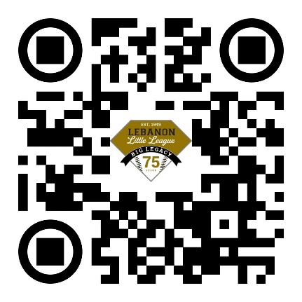
Thank You,
2024 Lebanon Little League Board of Directors
Lebanonll.org
info@lebanonll.org

